Juliana Hincapié – Maricela Jaramillo – Rosa Acosta
Lengua, lenguaje y habla – Jorge Iván Jiménez
Evidencias de un signo
Marzo 07/14
The 10 concepts that mentions Pierce in his study of semiotic, are what I will use to describe or say; why does the sign is considered as a sign for the people in a community or a society?
We have choosen to engage the “cubicle number eight” located at the academic register of the UPB, for try explain everything that revolves around of a simply thing. Considering the pierce’s theory is possible to say that a sign is a sign if for me has sense and relation with something. When anybody arrives to ask for an academic processing immediately a person responsible in the system gives an appointment and is necessary to expect call any cubicle.
After, the person sat down to wait and her saw the misses sitting in their chair watching and writing in their computers, [firstness, sign and object] (the girl didn’t make references to nothing, maybe only she saw the things such as) later she saw her assigned appointment on the TV screen, while she walked “ she was thinking to ask because the ratings don’t appear at SIGAA” [Secondness,] because she looked at her and she thought that she was who would to solve her problem, that is to say, she found a relation between she and something else. [Representamen] is similar to the previous category; in her mind she made an idea in relation with its object. Finally the responsible girl explained her that was a mistake of the system, but maybe it solve quickly. Here is present the Thirdness this is the result of to connect between the two other happening, giving as resulting a relation with each of them. [Interpretant] for us is in middle of the representament and object, is the modification that we do in our thought produced for the sign. So, the girl that attend us was not the responsible but a surrogate charge, this was our conclusion.
For last, regarding the pierce’s theory of signs and based in the three types of signs, the sign that we mentioned is in the degree iconic and indexical, this is because is similar to the object and keeps relation, is to say the Icon is like the object that a we looked in first instance (the girl sitting on a chair) the Index is (the perception that we had in our mind when we was walking to her office) and the symbol (was represented at the moment when we sat and understood what is the role that she represents in that office.)
Finally with the picture we try to show that a sign can represent different things in the mind of everybody creating an equivalent sign to the subjective reality.
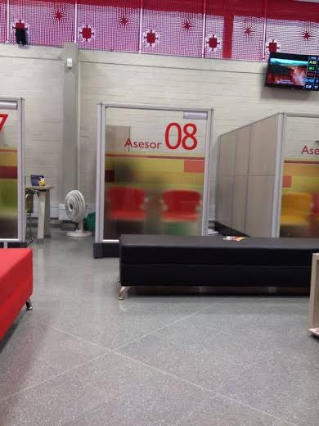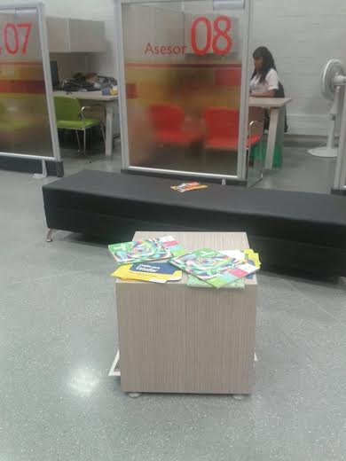
Cubicle number eight
These pictures were taken at academic register by our classmates Rosa Andrea Acosta.

